Digital Sales Performance Management SQL Queries

Use Ecommerce_Database

Select * from ecommerce_data

Select * from us_state_long_lat_codes

1. KPI Banner — YTD Sales, Profit, Quantity, Profit Margin (2022)

SELECT

MIN(order_date) AS First_Order_Date,

MAX(order_date) AS Last_Order_Date

FROM ecommerce_data;

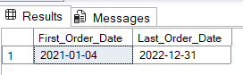

SELECT

SUM(sales_per_order) AS YTD_Sales,

SUM(profit_per_order) AS YTD_Profit,

SUM(order_quantity) AS YTD_Quantity,

ROUND(SUM(profit_per_order) / SUM(sales_per_order) * 100, 2) AS YTD_Profit_Margin

FROM ecommerce_data

WHERE YEAR(order_date) = 2022;

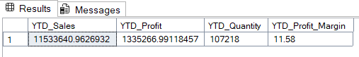

2. Year-on-Year (Sales, Profit, Quantity, Margin)

SELECT

YEAR(order_date) AS [Year],

SUM(sales_per_order) AS Total_Sales,

SUM(profit_per_order) AS Total_Profit,

SUM(order_quantity) AS Total_Quantity,

ROUND(SUM(profit_per_order) / SUM(sales_per_order) * 100, 2) AS Profit_Margin

FROM ecommerce_data

GROUP BY YEAR(order_date)

ORDER BY [Year];

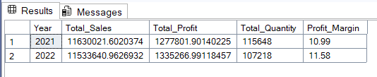

3. YTD, PYTD, and YoY Growth by Customer Segment (2021 vs 2022)

WITH ytd AS (

SELECT customer_segment, SUM(sales_per_order) AS YTD_Sales

FROM ecommerce_data

WHERE YEAR(order_date) = 2022

GROUP BY customer_segment

),

pytd AS (

SELECT customer_segment, SUM(sales_per_order) AS PYTD_Sales

FROM ecommerce_data

WHERE YEAR(order_date) = 2021

GROUP BY customer_segment

)

SELECT

ytd.customer_segment,

ytd.YTD_Sales,

pytd.PYTD_Sales,

ROUND(((ytd.YTD_Sales - pytd.PYTD_Sales) / NULLIF(pytd.PYTD_Sales, 0)) * 100, 2) AS YoY_Growth_Percent

FROM ytd

JOIN pytd ON ytd.customer_segment = pytd.customer_segment;

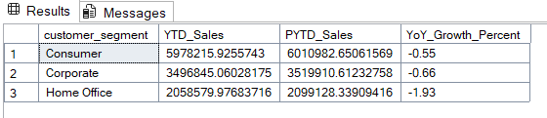

4. YTD Sales by State (2022)

SELECT

customer_state,

SUM(sales_per_order) AS YTD_Sales

FROM ecommerce_data

WHERE YEAR(order_date) = 2022

GROUP BY customer_state

ORDER BY YTD_Sales DESC;

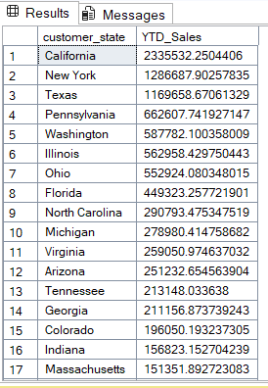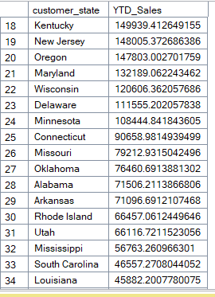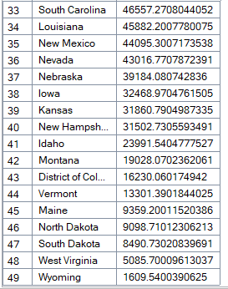

5. Top 5 and Bottom 5 Products by Sales (All-Time)

-- Top 5

SELECT TOP 5 product_name, SUM(sales_per_order) AS Total_Sales

FROM ecommerce_data

GROUP BY product_name

ORDER BY Total_Sales DESC;

-- Bottom 5

SELECT TOP 5 product_name, SUM(sales_per_order) AS Total_Sales

FROM ecommerce_data

GROUP BY product_name

ORDER BY Total_Sales ASC;

TOP 5

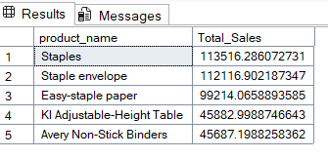

BOTTOM 5

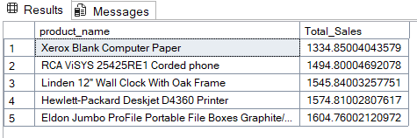

6. YTD Sales by Region (2022)

SELECT

customer_region,

SUM(sales_per_order) AS YTD_Sales

FROM ecommerce_data

WHERE YEAR(order_date) = 2022

GROUP BY customer_region

ORDER BY YTD_Sales DESC;

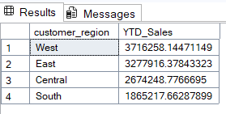

7. YTD Sales by Shipping Type (2022)

SELECT

shipping_type,

SUM(sales_per_order) AS YTD_Sales,

ROUND(

SUM(sales_per_order) * 100.0 /

(SELECT SUM(sales_per_order) FROM ecommerce_data WHERE YEAR(order_date) = 2022)

, 2) AS Sales_Percentage

FROM ecommerce_data

WHERE YEAR(order_date) = 2022

GROUP BY shipping_type

ORDER BY Sales_Percentage DESC;

